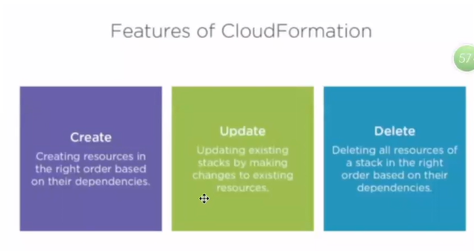

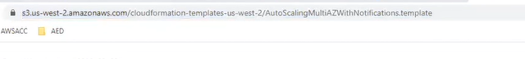

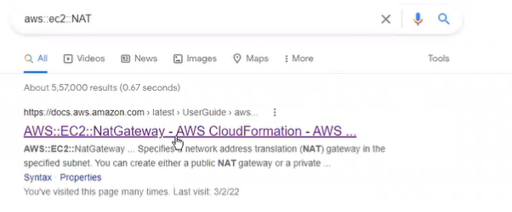

"NATGateway" : {

"Type" : "AWS::EC2::NatGateway",

"Properties" : {

"AllocationId" : {

"Fn::GetAtt" : ["NATGatewayEIP", "AllocationId"]

},

"SubnetId" : {

"Ref" : "PublicSubnet"

},

"Tags" : [

{"Key" : "stack", "Value" : "production" }

]

}

},

"NATGatewayEIP" : {

"Type" : "AWS::EC2::EIP",

"Properties" : {

"Domain" : "vpc"

}

},

"RouteNATGateway" : {

"DependsOn": [ "NATGateway" ],

"Type" : "AWS::EC2::Route",

"Properties" : {

"RouteTableId" : { "Ref" : "PrivateRouteTable" },

"DestinationCidrBlock" : "0.0.0.0/0",

"NatGatewayId" : { "Ref" : "NATGateway" }

}

}